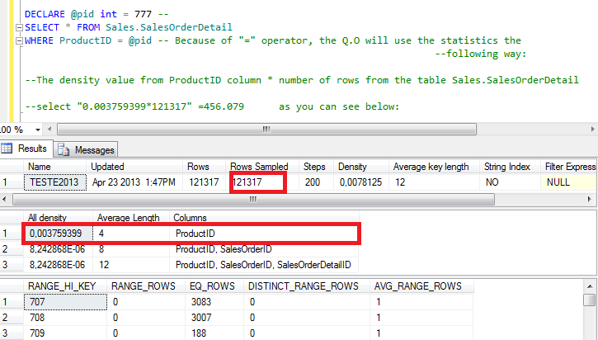

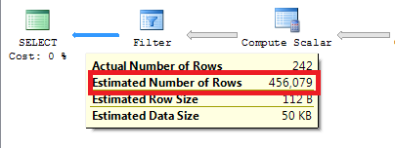

The way to calculate the Estimated Number of rows through the sargable search condition “>” and local variable.

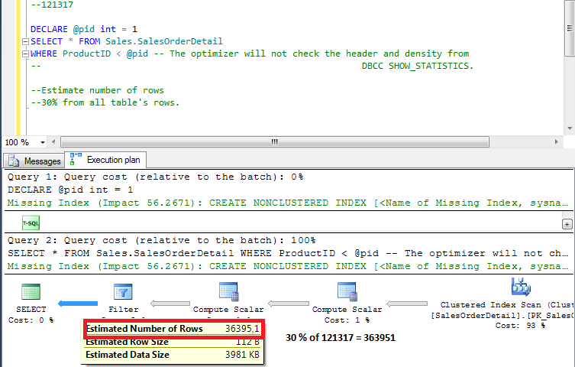

The output is 30% from all table rows

SELECT COUNT(*) FROM Sales.SalesOrderDetail;

--121317

DECLARE @pid int = 777 --

SELECT * FROM Sales.SalesOrderDetail

WHERE ProductID = 777 -- Because of "=" operator, the Q.O will use the statistics the

--following way:

OPTION(MAXDOP 1)

--The density value from ProductID column * number of rows from the table Sales.SalesOrderDetail

--select "0.003759399*121317" =456.079 as you can see below:

DBCC SHOW_STATISTICS('Sales.SalesOrderDetail',teste2013)

--

OPTION(MAXDOP 1)

--Estimate number of rows

--30% from all table's rows.

SELECT * FROM Sales.SalesOrderDetail

select *from sales.SalesOrderDetail where ProductID=870 and OrderQty=1

--2630.1

--rows=121317

sp_helpindex 'sales.SalesOrderDetail'

dbcc show_statistics('sales.SalesOrderDetail',IX_SalesOrderDetail_ProductID)

--density=0,003759399

--estimated number of rows=4688 (Colunm EQ_ROWS FROM dbcc_showstatistics)

select 4.688/121.317 --0.0386425645

go

dbcc show_statistics('sales.SalesOrderDetail',OrderQty)

--density=0,02439024

--estimated number of rows=68062,18 (Colunm EQ_ROWS FROM dbcc_showstatistics)

select 68.062/121.317 --0.5610260721

select 0.5610260721 * 0.0386425645 --0.02167948617730590045

select 0.02167948617730590045*121317

--2630.1 = 2630.09022457221992489265